Q-1. Create a numerical vector to store the odd numbers between 1 to 100.

Ans :-

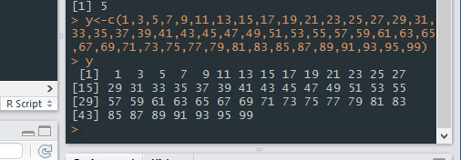

Q- Create the numerical vector with following values

• 1,2,3,4,5,8,6,2,11

Ans:

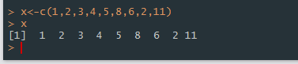

Q-Create 3x3 matrix from the vector.

Ans:

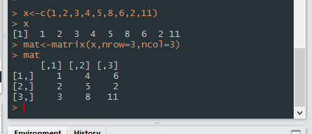

4. Consider the following vector a<-c(NA,11:15,NA,NA) remove all the NA and find the

mean of the vector

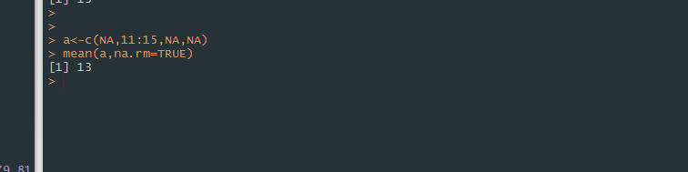

Q-5. Consider the vector x=c(”apple”,”banana”,”grape”)

Replace the first occurrence of a with ‘$’